***Section* 3.4 – Comparison Tests**

***Theorem***

Let , , and  be series with nonnegative terms. Suppose that for some integer *N*.



1. If  converges, then  also converges.
2. If  diverges, then  also diverges.

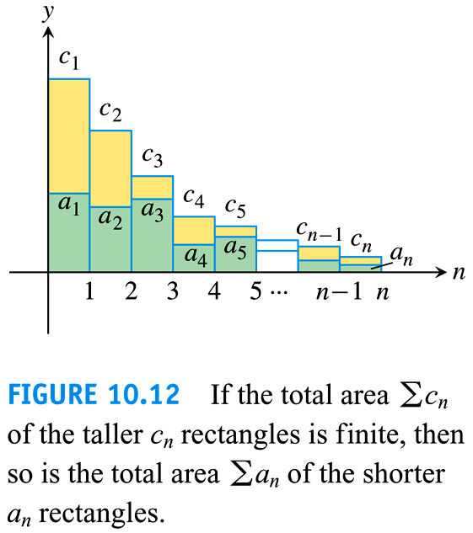

***Example***

Use the comparison Test to determine if  converges or diverges.

***Solution***





The series ***diverges*** because its *n*th term is greater than the *n*th term of the divergent harmonic series.

***Example***

Use the comparison Test to determine if  converges or diverges.

***Solution***





 is a geometric series 





The series ***converges***.

**Limit Comparison Test**

***Theorem***

Suppose that  and  for all  (*N* an integer)

1. If , then  and  both converge or both diverge
2. If  and  converges, then  converges
3. If  and  diverges, then  diverges

***Example***

Does the series  converge or diverge?

***Solution***





Let 



Since 





By the limit Comparison test  diverges

***Example***

Does the series  converge or diverge?

***Solution***

Let 

Since 







 converges by the Limit Comparison Test.

***Example***

Does the series  converge or diverge?

***Solution***

Let 









 diverges by the Limit Comparison Test.

***Example***

Does the series  converge?

***Solution***

Let 







 ***L’hôpital Rule***





 converges by the Limit Comparison Test.

***Exercises*** ***Section* 3.4 – Comparison Tests**

Use the Comparison Test to determine if the series converges or diverges.

|  |  |  |
| --- | --- | --- |
|  |  |  |

Use the Limit Comparison Test to determine if the series converges or diverges.

|  |  |  |
| --- | --- | --- |
|  |  |  |

Use any method to determine if the series converges or diverges

|  |  |  |
| --- | --- | --- |
|  |  |  |